Name: Vanshika Sahani
Student ID: AF05150751
Batch Code: ANP-D4970
Project Name: Crime Analytics Dashboard using PowerBI
Project Guide: Mr. Abhishek Pratap Singh

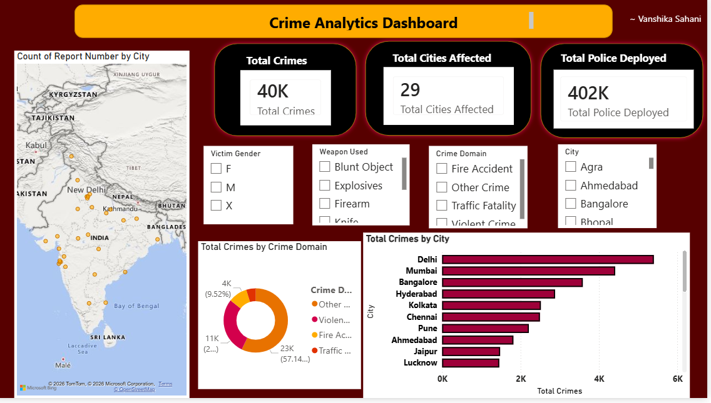
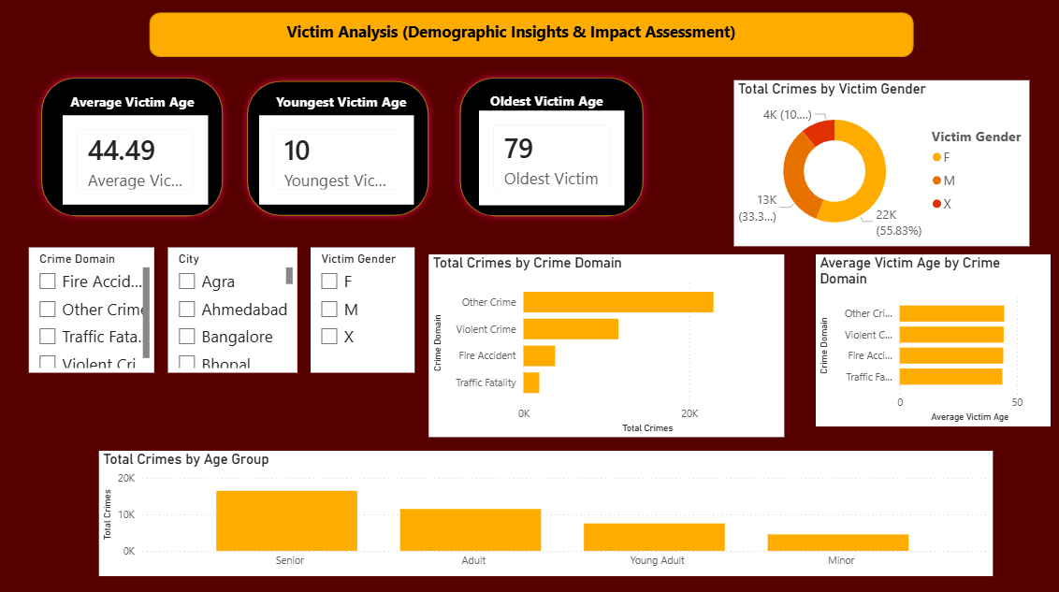
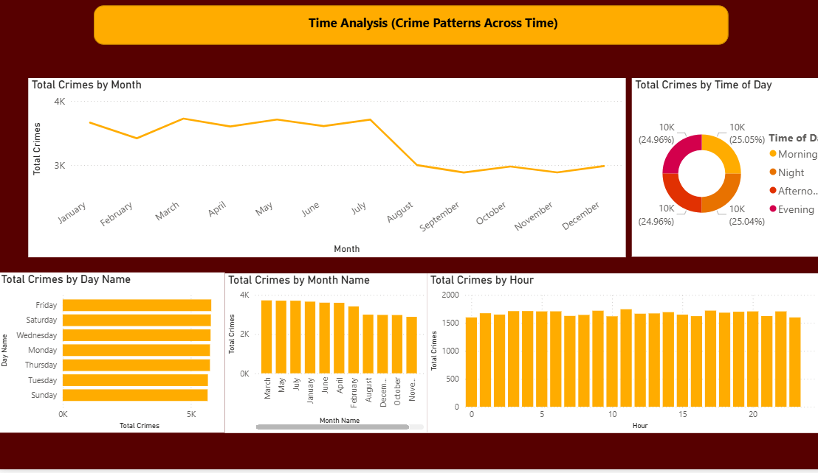
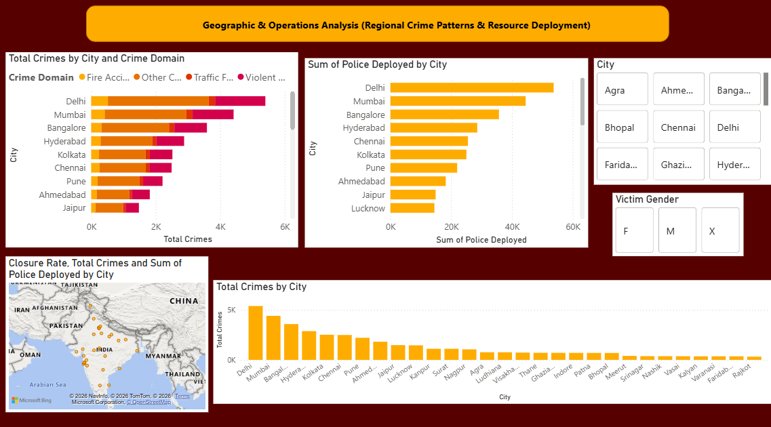

Objective
The objective of the Crime Analytics Dashboard is to analyze crime incidents, victim demographics, geographic crime distribution, and police deployment data through interactive visualizations. The dashboard helps authorities identify crime trends, affected regions, and operational requirements for better decision-making.
Key Objectives:
- Analyze overall crime statistics and patterns.
- Identify cities with the highest crime occurrences.
- Study victim demographics such as age and gender.
- Examine temporal crime trends based on day, month, and hour.
- Evaluate police deployment across different cities.
- Visualize crime distribution geographically using maps.

Problem Statement
Crime incidents occur across multiple cities and involve various crime domains, victim groups, and operational resources. Analyzing large volumes of crime data manually is time-consuming and inefficient.
This project aims to utilize Power BI to:
- Monitor overall crime statistics and affected regions.
- Analyze victim demographics and crime distribution.
- Identify crime trends across different time periods.
- Evaluate police deployment in various cities.
- Provide geographical insights into crime occurrences and closure rates.
- Support law enforcement agencies with data-driven decision-making.

Data Description
Source:
The dataset consists of crime records containing information about crime incidents, victims, police deployment, locations, and crime domains.
Attributes
Attribute Name | Data Type | Description
Crime_ID | Integer | Unique crime identifier
City | String | City where crime occurred
Crime_Domain | String | Category/domain of crime
Victim_Gender | String | Gender of victim
Victim_Age | Integer | Age of victim
Weapon_Used | String | Weapon involved in crime
Police_Deployed | Integer | Number of police personnel deployed
Time_of_Day | String | Morning, Afternoon, Evening, Night
Month | String | Month of occurrence
Day | String | Day of occurrence
Hour | Integer | Hour of occurrence
Latitude | Float | Geographic latitude
Longitude | Float | Geographic longitude
Closure_Rate | Float | Percentage of crimes closed

Dashboard Structure
Page 1: Crime Analytics Overview
KPIs
- Total Crimes
- Total Cities Affected
- Total Police Deployed
Slicers
- Victim Gender
- Weapon Used
- Crime Domain
- City
Visualizations
- Crime Distribution Map
- Pie Chart: Total Crimes by Crime Domain
- Bar Chart: Total Crimes by City
Purpose
Provides an overall summary of crime incidents, affected cities, and police deployment.

Page 2: Victim Demographics Analysis
Visualizations
- Total Crimes KPI/Chart
- Pie Chart: Crimes by Victim Gender
- Bar Chart: Total Crimes by Age Group
Purpose
Analyzes victim characteristics and identifies demographic groups most affected by crime.

Page 3: Crime Time Analysis
Visualizations
- Pie Chart: Total Crimes by Time of Day
- Line Chart: Total Crimes by Month
- Bar Chart: Total Crimes by Day
- Bar Chart: Total Crimes by Month
- Bar Chart: Total Crimes by Hour
Purpose
Examines crime occurrence patterns across different time periods and identifies peak crime timings.

Page 4: Geographic and Operations Analysis
Slicers
- Victim Gender
- City
Visualizations
- Map: Closure Rate by Location
- Bar Chart: Sum of Police Deployed by City
- Bar Chart: Total Crimes by City
- Bar Chart: Total Crimes by Crime Domain
Purpose
Provides insights into police resource allocation, crime distribution, and closure performance across regions.
Approach
1. Data Import
- Import crime dataset into Power BI.
- Verify data quality and structure.
2. Data Cleaning
- Handle missing values.
- Remove duplicate records.
- Standardize city and crime domain names.
3. Data Transformation
- Create age groups for victim analysis.
- Generate month, day, and hour dimensions.
- Create calculated measures using DAX.
4. Dashboard Development
- Design KPI cards.
- Develop interactive charts and maps.
- Implement slicers for dynamic filtering.

Project Result
Crime Overview
- Identified total crimes reported across multiple cities.
- Determined cities with the highest crime occurrences.
- Measured total police deployment.
Victim Analysis
- Analyzed victim distribution by gender.
- Identified age groups most affected by crime.
Time-Based Analysis
- Determined peak crime months, days, and hours.
- Visualized crime trends throughout the year.
Geographic and Operational Analysis
- Compared police deployment across cities.
- Evaluated crime distribution by city and domain.
- Visualized closure rates geographically.

Conclusion
The Crime Analysis Dashboard successfully transforms raw crime data into meaningful insights using Power BI. Through KPI cards, maps, pie charts, bar charts, and trend visualizations, the dashboard enables effective monitoring of crime patterns, victim demographics, geographic distribution, and police operations.
The dashboard serves as a valuable decision-support tool for law enforcement agencies by helping identify crime hotspots, optimize police deployment, and understand temporal crime trends. Future enhancements may include predictive crime analytics and real-time crime monitoring capabilities.

